# **SHRI VAISHNAV VIDHYAPEETHVISHWAVIDHYALAYA SHRI VAISHNAV INSTITUTE OF INFORMATIONTECHNOLOGY**

**DEPARTMENT OF COMPUTER SCIENCE AND ENGINEERNG**



**PRACTICAL FILE**

**On**

**Social Networking Site**

**Software Engineering and Project Management**

**[BTCS504]**

**Submitted to: Submitted by:**

Mr. Virendra Dani Abhay Soni

Assistant Professor CS (I)

CSE Department III Year/V Sem

2010DMBCSE07783

**SESSION: July-Dec 2022**

**TABLE OF CONTENTS**

|  |  |
| --- | --- |
| **Index** | **Page No.** |
| 1. Introduction | 6 |
| 1.1 Objectives | 8 |
| 1.2 Identification of Need | 8 |
| 1.3 Preliminary Investigation | 9 |
| 1.4 Problem Domain | 9 |
| 1.5 Solution Domain | 9 |
| 1.6 Platform Specification | 10 |
| 1.6.1 Hardware | 10 |
| 1.6.2 Software | 10 |
| 1. System Requirement Analysis | 11 |
| 2.1 Information Gathering | 12 |
| 2.1.1 Functional Requirement | 13 |
| 2.1.2 Non- Functional Requirement | 13 |
| 2.2 System Feasibility | 14 |
| 2.2.1 Operational | 14 |
| 2.2.2 Technical | 14 |
| 2.2.3 Economical | 15 |
| 1. System Design | 16 |
| 3.1 Use Case Diagram | 18 |
| 3.2 Class Diagram | 19 |
| 3.3 Sequence Diagram | 20 |
| 3.4 Activity Diagram | 21 |
| 1. Design | 22 |
| 4.1 Data Design | 23 |
| 4.1.1 ER Diagram | 24 |
| 4.2 System Architecture | 25 |
| 1. Implementation | 26 |
| 5.1 Implementation of Modules | 28 |
| 5.2 Results | 29 |
| 1. Testing | 33 |
| 6.1Testing Objectives | 34 |
| 6.2Testing Scope | 34 |
| 6.3 Testing Principles | 35 |
| 6.4Testing Method Used | 36 |
| 6.5 Test Cases | 37 |
| 6.6 Sample Test Data and Results | 41 |
| 1. Limitation | 45 |
| 1. Future Scope | 47 |
| 1. Conclusion | 49 |
| 1. Bibliography and References | 51 |

**LIST OF FIGURES**

|  |  |  |
| --- | --- | --- |
| **Figure No.** | **Title** | **Page No.** |
| 01 | Use Case Diagram of Social Networking Site | **18** |
| 02 | Class Diagram of Social Networking Site | **19** |
| 03 | Sequence Diagram of Social Networking Site | **20** |
| 04 | Activity Diagram of Social Networking Site | **21** |
| 05 | ER Diagram of Social Networking Site | **24** |
| 06 | Implementation of Social Networking Site | **27** |
| 07 | Implementation of module of Social Networking Site | **28** |

**LIST OF TABLES**

|  |  |  |
| --- | --- | --- |
| **Figure No.** | **Title** | **Page No.** |
| 01 | Test Case for Admin | 38 |
| 02 | Test Case for User | 39 |

**INTRODUCTION**

**1. Introduction:**

Software Requirements Specification (SRS) provides an overview of the entire SRS with purpose, scope, definitions, acronyms, abbreviations, references and overview of the SRS. The aim of this document is to gather and analyze and give an in-depth in sight of the complete **Social Networking Site (Pictogrampg)** by defining the problem statement in detail. Nevertheless, it also concentrates on the capabilities required by stakeholders and their needs while defining high-level product features. The detailed requirements of the **Social Networking Site (Pictogrampg)** are provided in this document.

Following are the features of a good SRS document:

1. Correctness: User review is used to provide the accuracy of requirements stated in the SRS. SRS is said to be perfect if it covers all the needs that are truly expected from the system.

2. Completeness: The SRS is complete if, and only if, it includes the following elements:

(1). All essential requirements, whether relating to functionality, performance, design, constraints, attributes, or external interfaces.

(2). Definition of their responses of the software to all realizable classes of input data in all available categories of situations

(3). Full labels and references to all figures, tables, and diagrams in the SRS and definitions of all terms and units of measure.

3. Consistency: The SRS is consistent if, and only if, no subset of individual requirements described in its conflict.

4. Unambiguousness: SRS is unambiguous when every fixed requirement has only one interpretation. This suggests that each element is uniquely interpreted. In case there is a method used with multiple definitions, the requirements report should determine the implications in the SRS so that it is clear and simple to understand.

5. Ranking for importance and stability: The SRS is ranked for importance and stability if each requirement in it has an identifier to indicate either the significance or stability of that particular requirement.

6. Modifiability: SRS should be made as modifiable as likely and should be capable of quickly obtain changes to the system to some extent. Modifications should be perfectly indexed and cross-referenced.

7. Verifiability: SRS is correct when the specified requirements can be verified with a cost-effective system to check whether the final software meets those requirements. The requirements are verified with the help of reviews.

8. Traceability: The SRS is traceable if the origin of each of the requirements is clear and if it facilitates the referencing of each condition in future development or enhancement documentation.

9. Design Independence: There should be an option to select from multiple design alternatives for the final system. More specifically, the SRS should not contain any implementation details.

10. Testability: An SRS should be written in such a method that it is simple to generate test cases and test plans from the report.

11. Understandable by the customer: An end user may be an expert in his/her explicit domain but might not be trained in computer science. Hence, the purpose of formal notations and symbols should be avoided too as much extent as possible. The language should be kept simple and clear.

12. The right level of abstraction: If the SRS is written for the requirements stage, the details should be explained explicitly. Whereas, for a feasibility study, fewer analysis can be used. Hence, the level of abstraction modifies according to the objective of the SRS.

**1.1. Objectives:**

The Objective if this software is to completely automate the following processes:

* The main objective of the project is to establish a network among the people residing in all over the world. All the information can be easily accessed and shared among the people.
* This system provides users to register their various types of profile like social, personal, general, professional.
* This system provides users to send a scrap message, images and music files to their friends. User can maintain the scrap book whatever scraps he has send to users.
* The system provides user to upload the photos so that user can maintain own album.
* This system provides user to join the communities according to their scenario.
* This system provides the user to maintain their friend list and user can update their friend list.
* This system provides the user to send invitation to another friend to join the friend and can add to their friend list for future.

**1.2. Identification of need:**

Social networks are important because they allow people to develop relationships that might not be possible due to distance of place and time. They also help boost of business productivity when used for public relations, marketing, and advertising purposes.

This software is developed keeping in mind the above mentioned problems. The needs and requirements of the end users are also kept in mind while designing this software. This software will enable its users to maintain their friend list and user can update their friend list as well as we want to establish a network among the people residing in all over the world. All the information can be easily access and shared among the people.

**1.3. Preliminary Investigation:**

Social media is the process of trust building, with particular attention to the case of small-medium enterprises (SME). Our findings show that social media contribute to increase the effective trust more than traditional websites. This result suggests that social media have the potential to enhance the business of SMEs other than large companies, by fostering the affective commitment of customers.

**1.4. Problem Domain:**

The main problem was when user try to create account on that page admin has to verify it and give permission for creating account.

And second problem is arising was that it was crashing continuously due to domain side and admin has user password and id too.

**Pictogrampg** is an online social network service by which user can establish network among the people residing all over the world. All their information can be easily accessed and shared among the people.

This system provides users to register the various types of profile like social, personal, general, professional, send scrap messages to friends including music, images.

User can maintain the scrapbook whatever scraps he has send to users, upload the photos so that user can maintain own album and many more.

**1.5. Solution Domain:**

For removing crash problem, we have to remove permission section and we remove that section in which we get the user’s password too for security reason.

**1.6. Platform Specification:**

**1.6.1. Hardware:**

Since the application must run over the internet, all the hardware shall require to connect internet will be hardware interface for the system. As for e.g. Modem, WAN – LAN, Ethernet Cross-Cable.

* **Processor :** Intel Pentium IV 2.0 GHz and above
* **Ram :** 512 MB and above
* **Hard disk :** 80 GB and above
* **Free disk space :** 300 GB

**1.6.2. Software:**

* **Front End Client:** Microsoft visual studio.net with C#
* **Data Base Server:** DB2
* **Back End:** Microsoft SQL server
* **Operating system:** Window XP or above
* **Browser:** Any latest browser

**SYSTEM REQUIREMENT**

**ANALYSIS**

**2. System Requirement Analysis:**

The purpose of System Requirements Analysis is to obtain a thorough and detailed understanding of the business need as defined in Project Origination and captured in the Business Case, and to break it down into discrete requirements, which are then clearly defined, reviewed and agreed upon with the Customer Decision-Makers. During System Requirements Analysis, the framework for the application is developed, providing the foundation for all future design and development efforts.

**2.1. Information Gathering:**

* **Learning from the mistakes**

Problems occurring in the previous website: The main problem was when user try to create account on that page admin has to verify it and give permission for creating account.

And second problem is arising was that it was crashing continuously due to domain side and admin has user password and id too.

* **Focusing on one or two platforms**

We can develop a strategy for your social media, and that involves picking the best platforms for your company. Although we may eventually have the time and resources to maintain a presence on the entire social networks available to us, it’s best to focus on one or two when we’re just starting out.

* **Inviting satisfied software users to add reviews**

For example; Facebook business pages allow other users to leave reviews. While the lack of control you have over them may be intimidating, you can boost your rating by simply asking happy customers to rate your business.

* **Engaging with the followers**

It’s time to open the door for a back-and-forth conversation. The next time someone comments on one of your posts or leaves a review, thank them in the comments section. This only takes seconds to do, but can go a long way in showing that person that you genuinely appreciate their feedback.

**2.1.1 Functional Requirement:**

User should have valid User ID and password to login.

If users have not created their account in this site, they have to create a new account for using this site.

User should not be allowed to create more than one account.

User can edit their account related to their need.

**2.1.1 Non-functional Requirement:**

It should be secure and website should run smoothly and fast to get faster access to it

Website can be visited anywhere in the world where internet facility is available.

A proper help should be provided to use this website.

Unique password and logins assigned to every user for safety and privacy purpose.

It should be noted that illegal duplication of all the reports should be strictly dealt with.

**2.2. System Feasibility:**

Feasibility Study in Software Engineering is a study to evaluate feasibility of proposed project or system. Feasibility study is one of stage among important four stages of Software Project Management Process.

Feasibility study is made to see if project on competition will serve the purpose of the organization for the amount of work, effort and the time that spend on it. Feasibility study of a system proposal is according to its workability, which is the impact on the organization, ability to meet their user needs and effective use of resources. Thus when a new application is proposed it normally goes through a feasibility study before it is approved for development.

The document provide the feasibility of the project that is being designed and lists various areas that were considered very carefully during the feasibility study of this project such as Technical , Economical and Operational.

**2.2.1 Operational:**

This system is used for communication and building social relationships, can meet the conditions both in hardware and software; therefore, this system is feasible in operation.

**2.2.2 Technical:**

The system must be evaluated from the technical point of view. The assessment of this feasibility must be based on an outline design of the system requirement in the terms of input, output. Programs and procedures. Having identified an outline system , the investigation must go on to suggest the type of equipment , required method developing the system , of running the system once it has been designed.

Technical issues raised during the investigation are:

* Does the existing technology sufficient for the suggested one?
* Can the system expand if developed?

The project should be developed such that the necessary functions and performance are achieved within the constraints. The project is developed within latest technology. Through the technology may become obsolete after some period of time, due to the fact that never version of the software supports older versions, the system may still be used. So there are minimal constraints involved with this project. The system has been developed using Java the project is technically feasible for development.

We as Analysts have identified the existing computer system (hardware & software) of the concerned department and have determined whether these technical resources are sufficient for the proposed system or not , we have found out thus , that the project is technically very much feasible. The hardware and software requirements are:

**IDE:** Net beans, My Eclipse

**Operating System:** Any as Windows, Linux.

The system software uses phpMyAdmin Server as the database of this System. Using 000webhost as the platform for code implementation, the design and development on the technology of this system and the condition of the hardware are satisfied, therefore, it is technically feasible.

**2.2.3 Economical:**

The developing system must be justified by cost and benefit. Criteria to ensure that effort is concentrated on project, which will give best, return at the earliest. One of the factors, which affect the development of a new system , is the cost it would require.

The following factors, which affect the important financial questions asked during preliminary investigation:

* The costs conduct a full system investigation.
* The cost of the hardware and software.
* The benefits in form of reduced costs or fewer costly errors.

Since the system is developed as part of project work , there is no manual cost to spend for the proposed system.

**SYSTEM DESIGN**

**3. System Design:**

System design is the phase that bridges the gap between problem domain and the existing system in a manageable way. This phase focuses on the solution domain, i.e. “how to implement?”

It is the phase where the SRS document is converted into a format that can be implemented and decides how the system will operate.

A good system design is to organize the program modules in such a way that are easy to develop and change. Structured design techniques help developers to deal with the size and complexity of programs. Analysts create instructions for the developers about how code should be written and how pieces of code should fit together to form a program.

**Importance:**

1. If any pre-existing code needs to be understood, organized, and pieced together.
2. It is common for the project team to have to write some code and produce original programs that support the application logic of the system.

Inputs to System Design

* Statement of work
* Requirement determination plan
* Current situation analysis
* Proposed system requirements including a conceptual data model, modified DFDs, and Metadata (data about data).

Outputs for System Design

* Infrastructure and organizational changes for the proposed system.
* A data schema, often a relational schema.
* Metadata to define the tables/files and columns/data-items.
* A function hierarchy diagram or web page map that graphically describes the program structure.
* Actual or pseudo code for each module in the program.
* A prototype for the proposed system.

**3.1 Use Case Diagram:**

A use case diagram is used to represent the dynamic behaviour of a system. It encapsulates the system's functionality by incorporating use cases, actors, and their relationships. It models the tasks, services, and functions required by a system/subsystem of an application. It depicts the high-level functionality of a system and also tells how the user handles a system.

Following are the purposes of a use case diagram given below:

* It gathers the system's needs.
* It depicts the external view of the system.
* It recognizes the internal as well as external factors that influence the system.
* It represents the interaction between the actors.

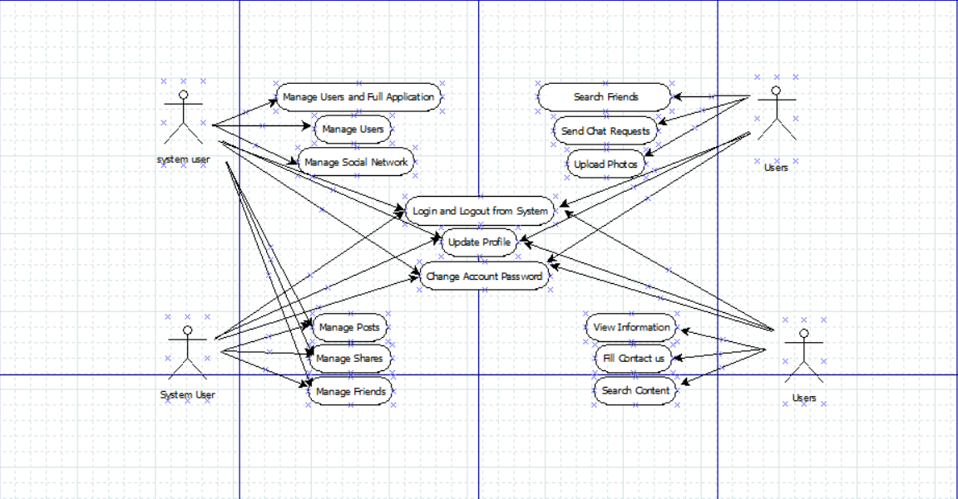

**Use Case Diagram of Social Networking Site**

**Figure.01**

**3.2 Class Diagram:**

Class diagram is a static diagram. It represents the static view of an application. Class diagram is not only used for visualizing, describing, and documenting different aspects of a system but also for constructing executable code of the software application. Class diagram describes the attributes and operations of a class and also the constraints imposed on the system. The purpose of class diagram is to model the static view of an application. Class diagrams are the only diagrams which can be directly mapped with object-oriented languages and thus widely used at the time of construction. The purpose of the class diagram can be summarized as −

* Analysis and design of the static view of an application.
* Describe responsibilities of a system.
* Base for component and deployment diagrams.
* Forward and reverse engineering.

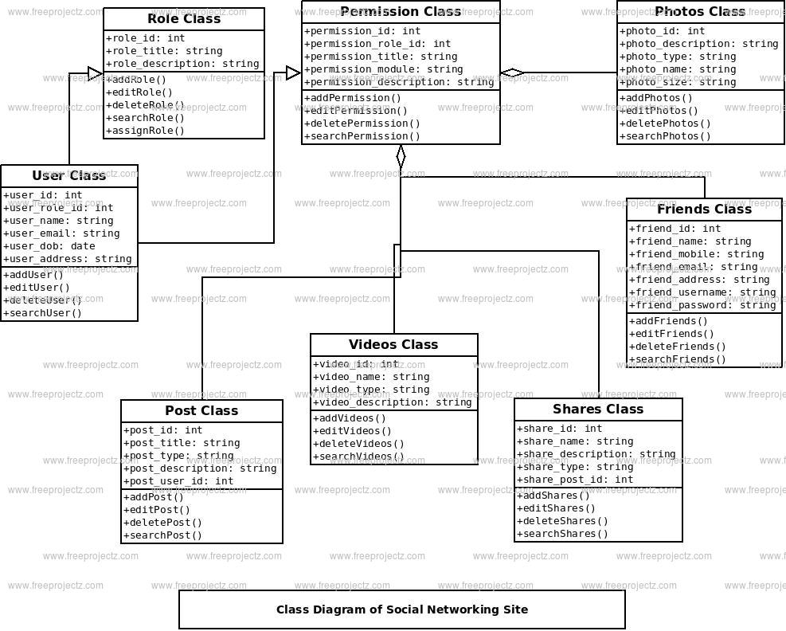

**Figure.02**

**3.3 Sequence Diagram:**

Sequence Diagrams – A sequence diagram simply depicts interaction between objects in a sequential order i.e. the order in which these interactions take place. We can also use the terms event diagrams or event scenarios to refer to a sequence diagram. Sequence diagrams describe how and in what order the objects in a system function. These diagrams are widely used by businessmen and software developers to document and understand requirements for new and existing systems.

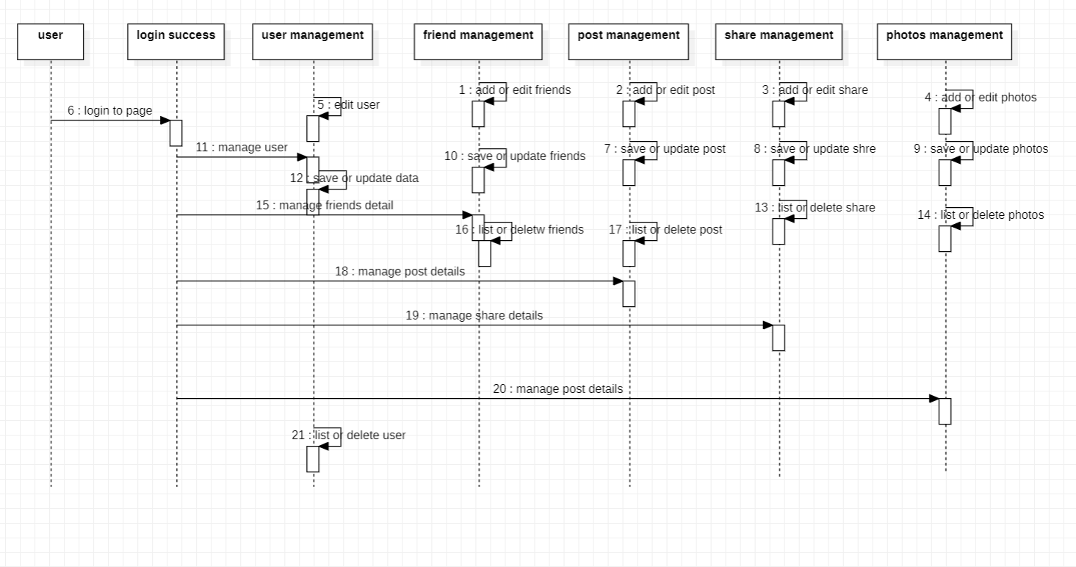

**\**

**Sequence Diagram of Social Networking Site**

**Figure.03**

**3.5 Activity Diagram:**

We use Activity Diagrams to illustrate the flow of control in a system and refer to the steps involved in the execution of a use case. We model sequential and concurrent activities using activity diagrams. So, we basically depict workflows visually using an activity diagram. An activity diagram focuses on condition of flow and the sequence in which it happens. We describe or depict what causes a particular event using an activity diagram . An activity diagram is a behavioural diagram i.e. it depicts the behaviour of a system. An activity diagram portrays the control flow from a start point to a finish point showing the various decision paths that exist while the activity is being executed. We can depict both sequential processing and concurrent processing of activities using an activity diagram. They are used in business and process modelling where their primary use is to depict the dynamic aspects of a system.

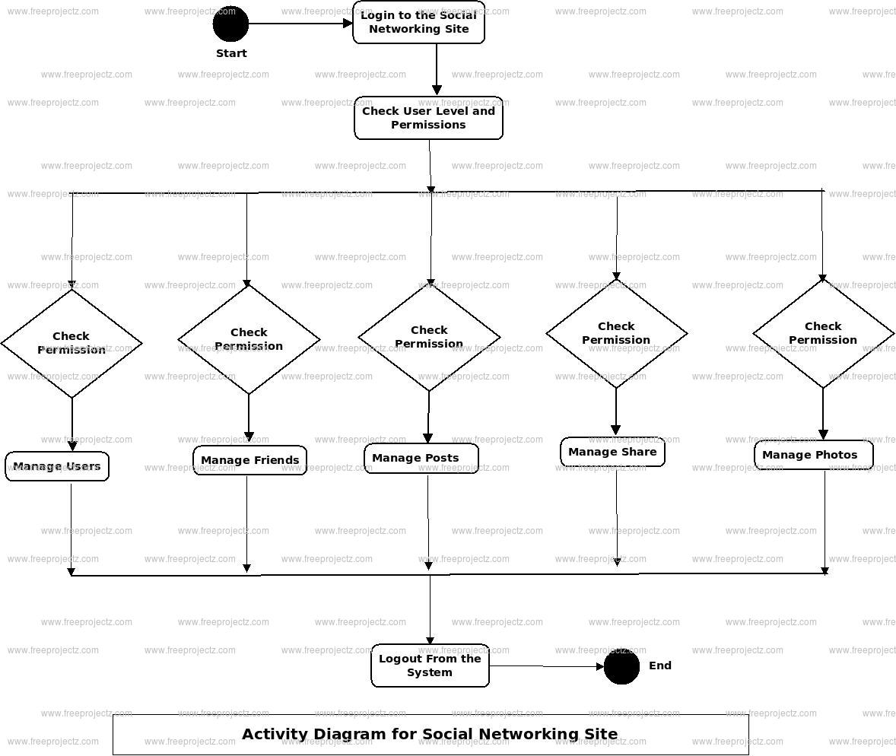

**Figure.04**

**DESIGN**

**4. Design :**

Software design is the process of envisioning and defining software solutions to one or more sets of problems. One of the main components of software design is the software requirements analysis (SRA). SRA is a part of the software development process that lists specifications used in software engineering.

**4.1 Data Design:**

A good SRS will break down the problem into chunks that can be solved more readily. This also helps to increase understanding of issues and makes them easier to tackle. Offers Design Input. Your SRS should contain design details to assist with implementation and deployment.

**Data design** is the first design activity, which results in less complex, modular and efficient program structure. The information domain model developed during analysis phase is transformed into data structures needed for implementing the software. The data objects, attributes, and relationships depicted in entity relationship diagrams and the information stored in data dictionary provide a base for data design activity.

**4.1.1 ER Diagram:**

Entity Relationship Diagram (aka ERD, ER Diagram, E-R Diagram) is a well-tried software engineering tool for data modeling, system design and illustrating the logical structure of databases. Introduced by Peter Chen the ER modeling technique is now successfully used in software development, when creating conceptual data model of an information system.

There are used three basic elements for ERDs construction: entities, attributes, relationships.

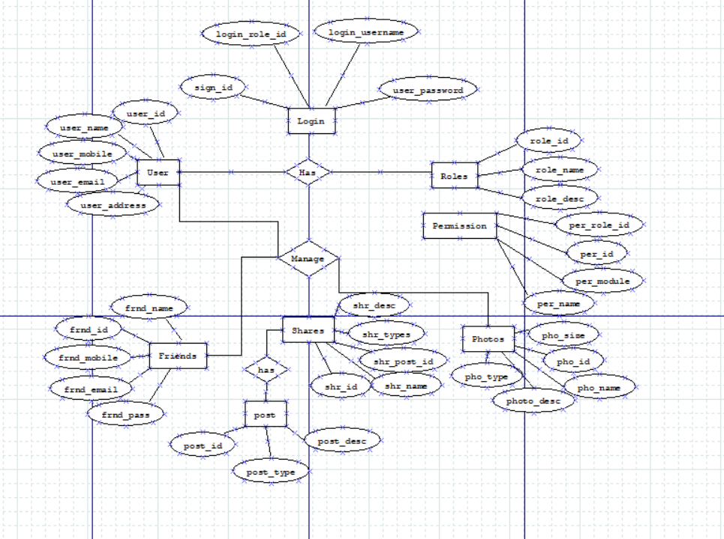

**ER Diagram of Social Networking Site**

**Figure.05**

**4.2 System Architecture:**

The software needs the architectural design to represents the design of software. IEEE defines architectural design as “the process of defining a collection of hardware and software components and their interfaces to establish the framework for the development of a computer system.” The software that is built for computer-based systems can exhibit one of these many architectural styles.

Architecture serves as a blueprint for a system. It provides an abstraction to manage the system complexity and establish a communication and coordination mechanism among components.

* It defines a structured solution to meet all the technical and operational requirements, while optimizing the common quality attributes like performance and security.
* Further, it involves a set of significant decisions about the organization related to software development and each of these decisions can have a considerable impact on quality, maintainability, performance, and the overall success of the final product. These decisions comprise of −
  + Selection of structural elements and their interfaces by which the system is composed.
  + Behavior as specified in collaborations among those elements.
  + Composition of these structural and behavioral elements into large subsystem.
  + Architectural decisions align with business objectives.
  + Architectural styles guide the organization**.**

**IMPLEMENTATION**

**5. Implementation:**

The social networking platform is implemented over the Elgg extensible social network framework. Elgg is open-source software written in PHP, uses MySQL for data persistence and supports jQuery for client-side scripting. The Elgg framework is structured around the following key concepts:

* ***Entities*** classes capturing concepts such as users, communities, application models, etc.
* ***Metadata*** describing and extending entities (e.g., a response to a question, a review of an application model, etc.).
* ***Relationships*** connecting two entities (e.g., user A is a friend of user B, user C is a contributor to an application model, etc.).

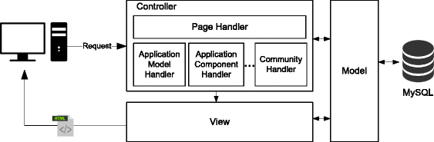

**Implementation of Social Networking Site**

**Figure.06**

**5.1 Implementation of modules:**

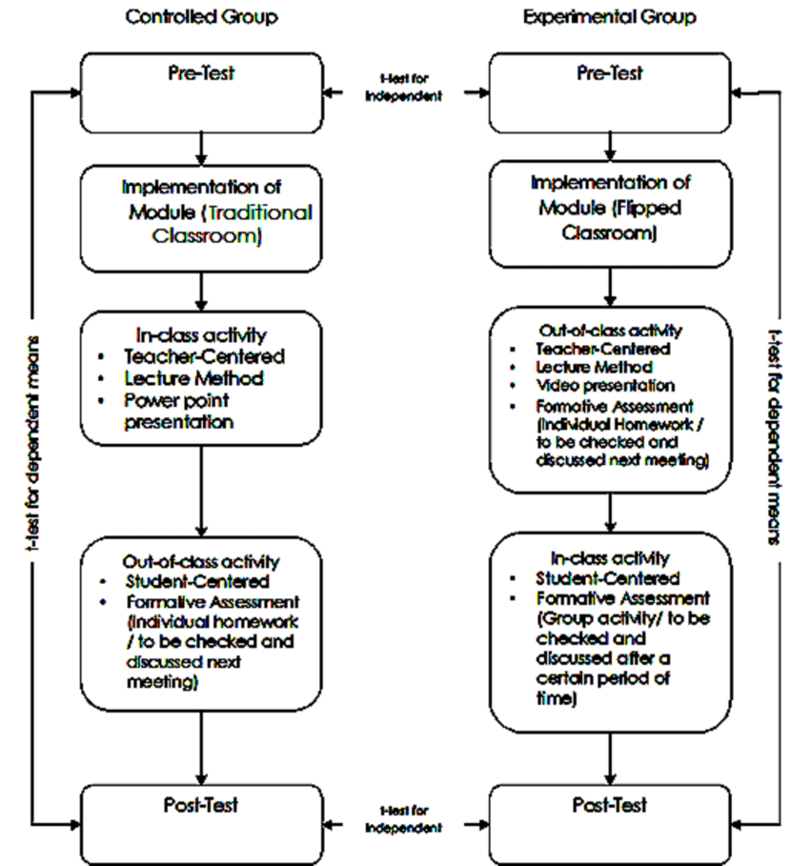

**Implementation of module of Social Networking Site**

**Figure.07**

**5.2 Results:**

An application has divided its working in different modules. Each module consists of different working for proper functioning of application. All modules are integrate together to make robust application. These modules provide various features of system.

•Photo & Video Galleries

•User profiles

•Private messaging system

•Friend buddy system

•Mutual friend system

•Activity steam/status update

•Groups with discussion board

•Add/remove custom applications system

**Some Screenshot of Site**

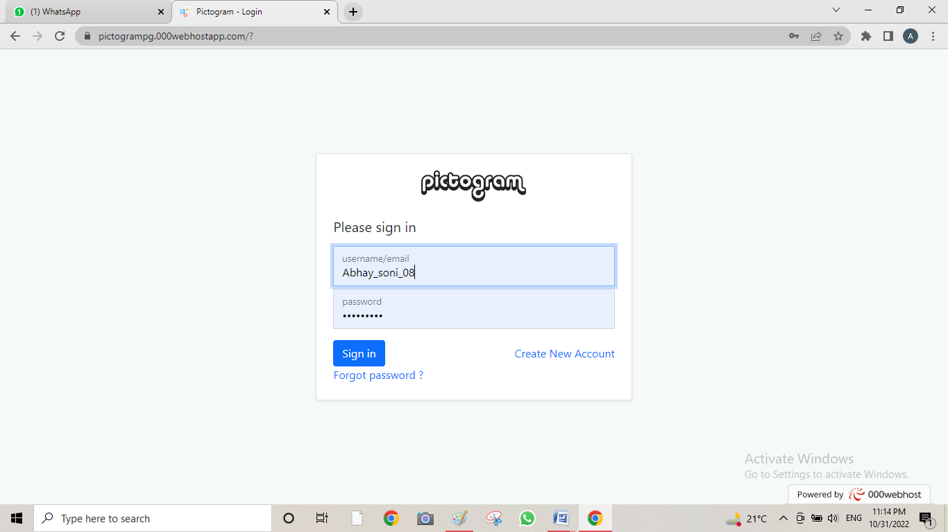

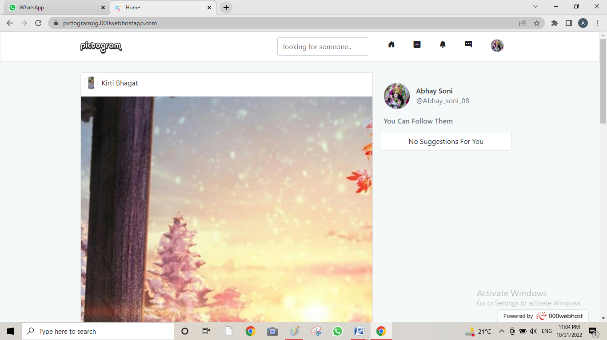

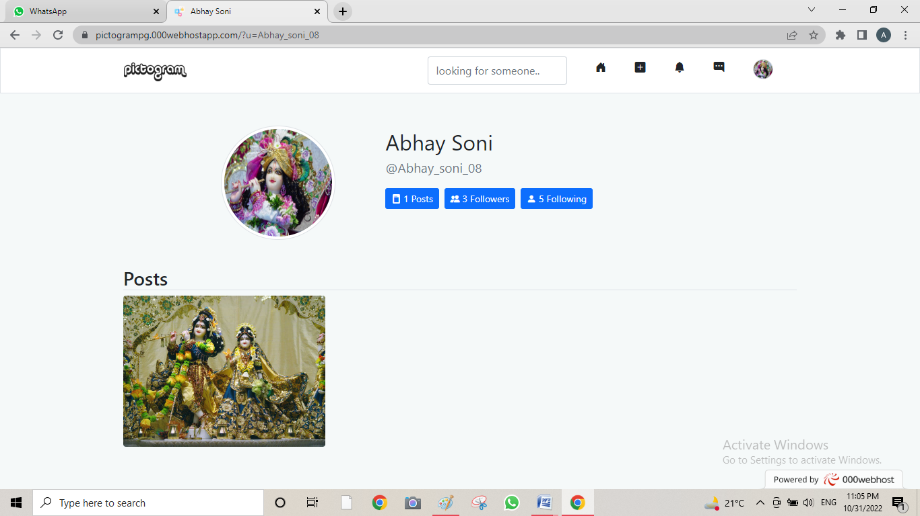

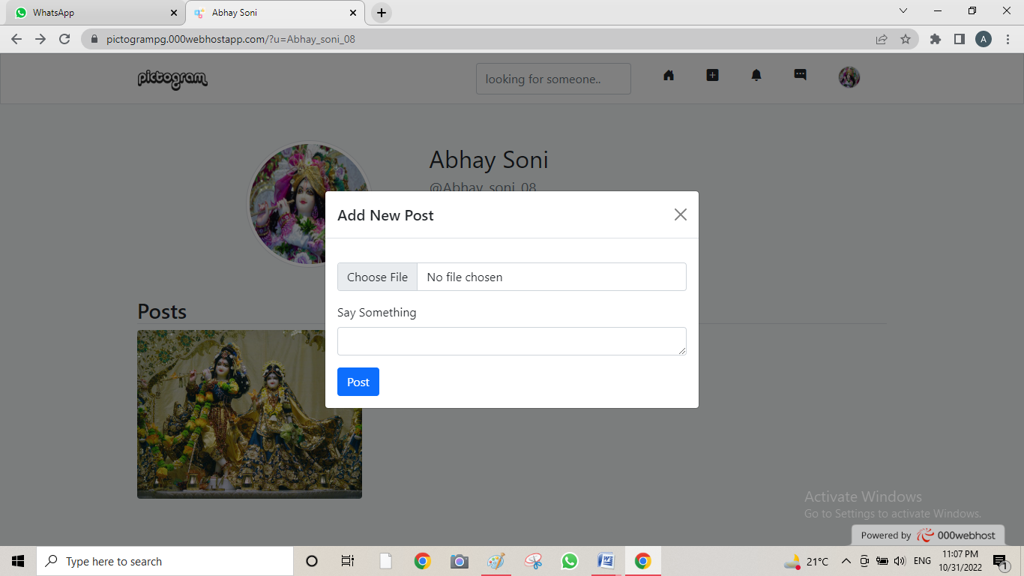

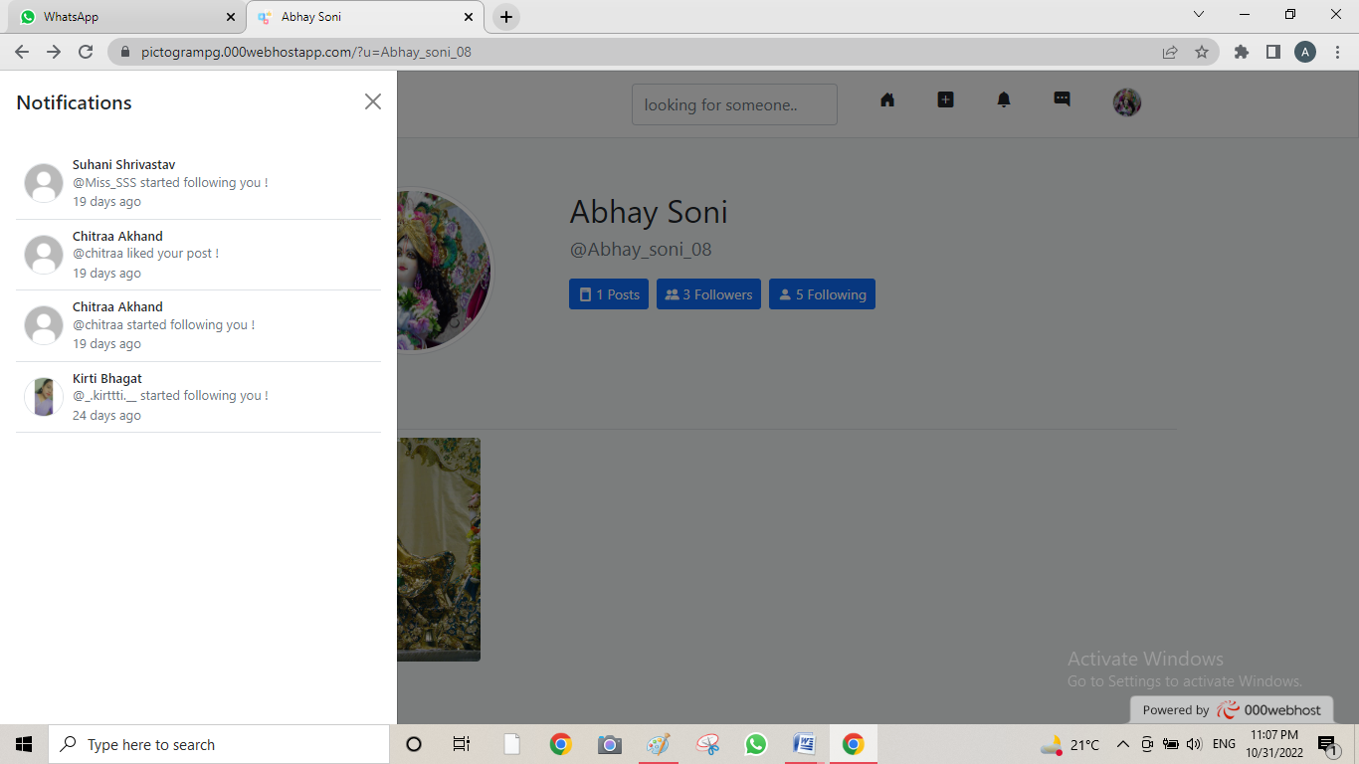

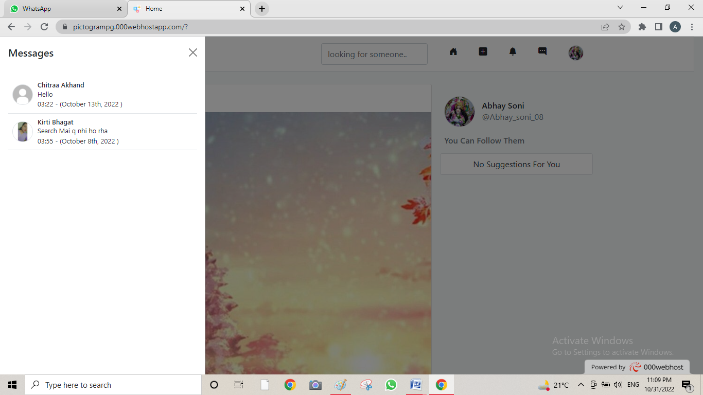

**TESTING**

**6. Testing:**

Software Testing is a method to check whether the actual software product matches expected requirements and to ensure that software product is Defect free. It involves execution of software/system components using manual or automated tools to evaluate one or more properties of interest. The purpose of software testing is to identify errors, gaps or missing requirements in contrast to actual requirements.

Software testing provides an independent view and objective of the software and gives surety of fitness of the software. It involves testing of all components under the required services to confirm that whether it is satisfying the specified requirements or not. The process is also providing the client with information about the quality of the software.

Testing is mandatory because it will be a dangerous situation if the software fails any of time due to lack of testing. So, without testing software cannot be deployed to the end user.

**6.1Testing Objectives:**

* Functional correctness: Validation that the website correctly supports required business processes and transactions. Also list any standards for which there is required compliance.
* Authorization: Verification that actions and data are available only to those users with correct authorization. List any key authorization requirements that must be satisfied, including access to functionality and data.
* Service level: Verification that the system will support the required service levels of the business. This includes system availability, load, and responsiveness. List any key performance indicators (KPIs) for service level, and the level of operational effort required to meet KPIs.
* Usability: Validation that the website meets required levels of usability. List the required training level and user KPIs required.

**6.2 Testing Scope:**

Testing is important because it provides data-driven insights about our social media marketing activities. It allows us to analyze how different variables, like photo and video, affect performance. Ultimately, it provide data about how audience behavior can influence the structure of your campaigns**.**

**6.3 Testing Principles:**

1. Testing shows the presence of defects, not their absence.
2. Exhaustive testing is impossible.
3. Early testing saves time and money.
4. Defects cluster together.
5. Beware of the pesticide paradox.
6. Testing is context dependent.
7. Absence-of-errors is a fallacy.

* **Testing shows the presence of defects:** The goal of software testing is to make the software fail. Software testing reduces the presence of defects. Software testing talks about the presence of defects and doesn’t talk about the absence of defects. Software testing can ensure that defects are present but it can not prove that software is defect-free. Even multiple testing can never ensure that software is 100% bug-free. Testing can reduce the number of defects but not remove all defects.
* **Exhaustive testing is not possible:** It is the process of testing the functionality of the software in all possible inputs (valid or invalid) and pre-conditions is known as exhaustive testing. Exhaustive testing is impossible means the software can never test at every test case. It can test only some test cases and assume that the software is correct and it will produce the correct output in every test case. If the software will test every test case then it will take more cost, effort, etc., which is impractical.
* **Early Testing:** To find the defect in the software, early test activity shall be started. The defect detected in the early phases of SDLC will be very less expensive. For better performance of software, software testing will start at the initial phase i.e. testing will perform at the requirement analysis phase.
* **Defect clustering:** In a project, a small number of modules can contain most of the defects. Pareto Principle to software testing state that 80% of software defect comes from 20% of modules.
* **Pesticide paradox:** Repeating the same test cases, again and again, will not find new bugs. So it is necessary to review the test cases and add or update test cases to find new bugs.
* **Testing is context-dependent:** The testing approach depends on the context of the software developed. Different types of software need to perform different types of testing. For example, The testing of the e-commerce site is different from the testing of the Android application.
* **Absence of errors fallacy:** If a built software is 99% bug-free but it does not follow the user requirement then it is unusable. It is not only necessary that software is 99% bug-free but it is also mandatory to fulfill all the customer requirements.

**6.4 Testing Method Used:**

* **Enterprise Software Testing**: Social media applications serve a large number of people and are very robust to test and require a high level of security testing. Hence these applications require some high-end enterprise testing solutions to be tested.
* **Web 2.0 testing**: Being a web 2.0 based application, testing of social media applications requires the early involvement of testers. These applications are also susceptible to frequent changes and hence automatization of the [test cases](https://www.testbytes.net/blog/test-cases-for-mobile-applications/) for such applications is preferred.
* [Web-testing](https://www.testbytes.net/blog/website-testing-2019/) including [compatibility](https://www.testbytes.net/blog/compatibility-testing/), [functional](https://www.testbytes.net/blog/functional-testing-7-best-practices/), [Security Testing](https://www.testbytes.net/blog/information-security-testing-guide-for-you/), [Performance Testing](https://www.testbytes.net/blog/software-performance-testing/) and [database testing](https://www.testbytes.net/blog/database-testing/) needs to be done for social media apps.
* **SaaS Testing:** SaaS is referred to software as a service model. Social media services follow the Saas model and are required to be validated for proper functioning using SaaS testing.
* **Web Analytics Testing**: Social media apps deal with a large amount of data, Web analytics testing helps in collecting of website data and then analyzing and reporting based on your user’s targets.
* **User Acceptance Testing:** includes testing social media apps for its attractiveness and user-friendly nature.
* **Content Management testing**: Content management testing validate that the content is appropriate for the audience. Social media applications like Facebook are an ocean of content, new content is posted every now and then, and hence, content management testing becomes an on-going task and is very important to avoid any content related issues.
* **SEO testing**: SEO is the need for the hour to promote your websites/applications online. Hence SEO testing becomes very important to ensure proper growth and exposure of your social media application.

**6.5 Test Cases:**

Test Case 1: By entering write and wrong login info.

Test Case 2: By posting the different media.

Test Case 3: By following or unfollowing peoples.

Test Case 4: By likes and comments on posts.

Test Case 5: By sending and receiving the text message with friends on text area.

Test Case 6: By blocking peoples.

Test Case 7: By Searching peoples.

And, So on ……..

**Test Case for Admin**

|  |  |  |  |  |
| --- | --- | --- | --- | --- |
| **Use case** | **User Input** | **Desired Output** | **Actual Output** | **Result** |
| Admin_Login | No entries filled | Error | Invalid Entry | Pass |
| Admin_Login | ------  Gfdfiu756 | Error | Invalid Entry | Pass |
| Admin_Login | Nisdfab\44567@gmail.com  Gfdfiu756 | Error | Invalid Entry | Pass |
| Admin_Login | [Soniabhay9547@gmail.com](mailto:Soniabhay9547@gmail.com)  Gfdfiu756 | Error | Invalid Entry | Pass |
| Admin_Login | Nisdfab\44567@gmail.com  -------- | Error | Invalid Entry | Pass |
| Admin_Login | ----------  As#940650 | Error | Invalid Entry | Pass |
| Admin_Login | Nisdfab\44567@gmail.com  As#940650 | Error | Invalid Entry | Pass |
| Admin_Login | [Soniabhay9547@gmail.com](mailto:Soniabhay9547@gmail.com)  As#940650 | No Error | Login Successful | Pass |

Tabel.01

**Test Case for User**

|  |  |  |  |  |
| --- | --- | --- | --- | --- |
| **Use case** | **User Input** | **Desired Output** | **Actual Output** | **Result** |
| User_Login | No entries filled | Error | Invalid Entry | Pass |
| User_Login | ------  Teyudy563 | Error | Invalid Entry | Pass |
| User_Login | Aerdfghj2345@gmail.com  Teyudy563 | Error | Invalid Entry | Pass |
| User_Login | [Kirtibhagat628@gmail.com](mailto:Kirtibhagat628@gmail.com)  Teyudy563 | Error | Invalid Entry | Pass |
| User_Login | Aerdfghj2345@gmail.com  -------- | Error | Invalid Entry | Pass |
| User_Login | ----------  Kirti08 | Error | Invalid Entry | Pass |
| User_Login | Aerdfghj2345@gmail.com  Kirti08 | Error | Invalid Entry | Pass |
| User_Login | [Kirtibhagat628@gmail.com](mailto:Kirtibhagat628@gmail.com)  Kirti08 | No Error | Login Successful | Pass |

Tabel.02

**Screenshot of login page**



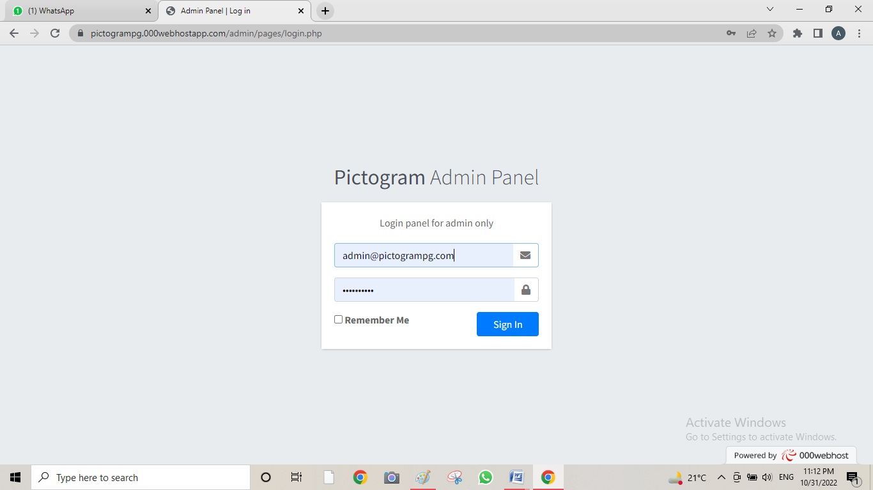

**6.6 Sample Test Data and Results:**

**Screenshot of Updated database during testing**

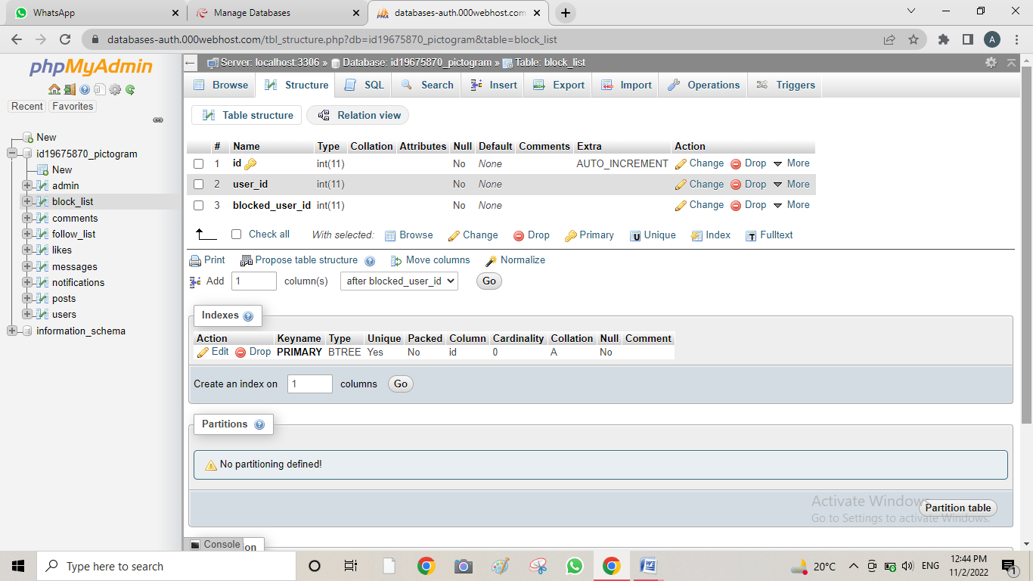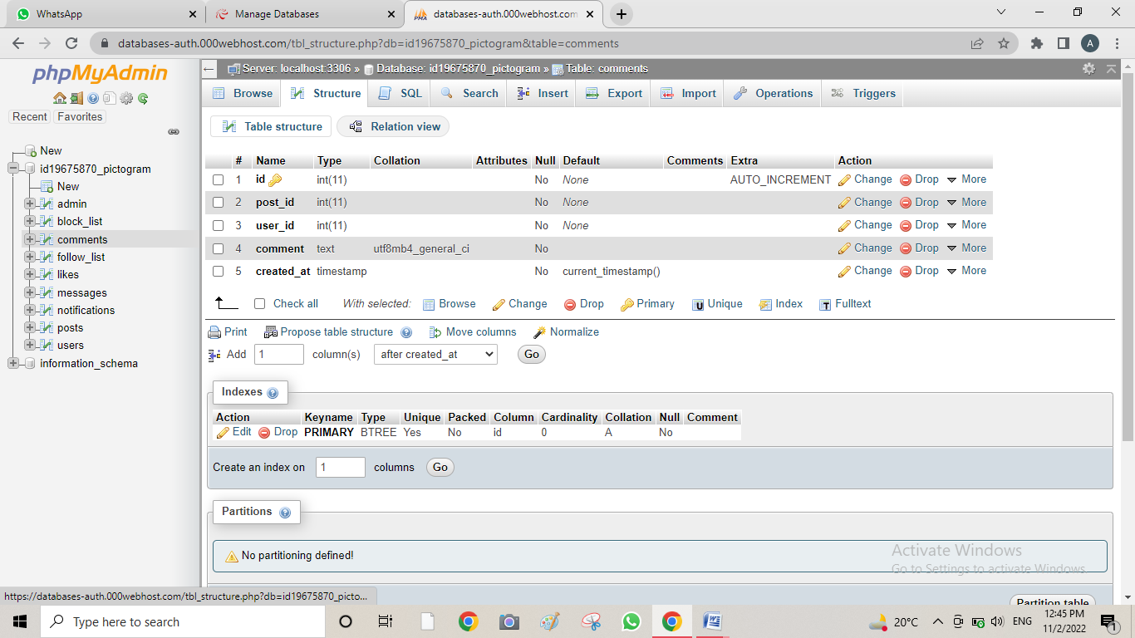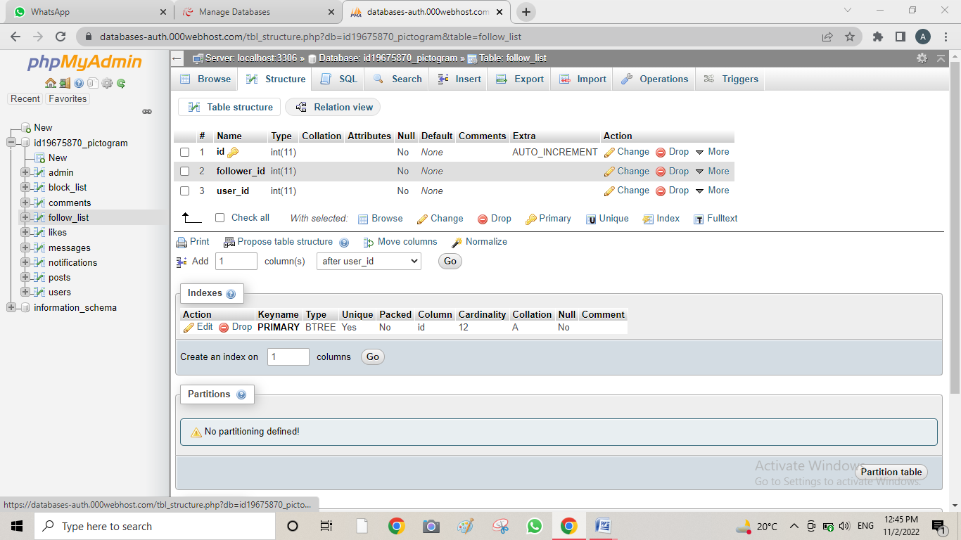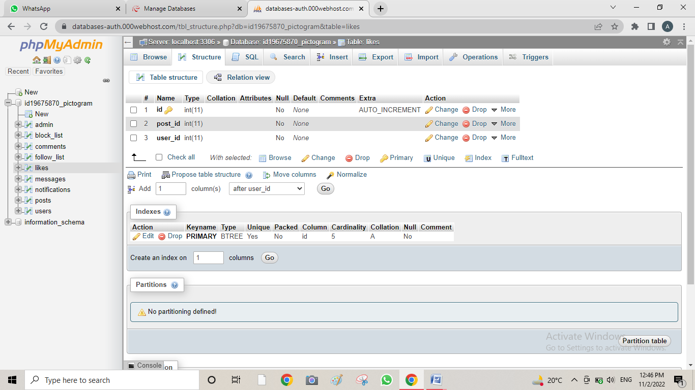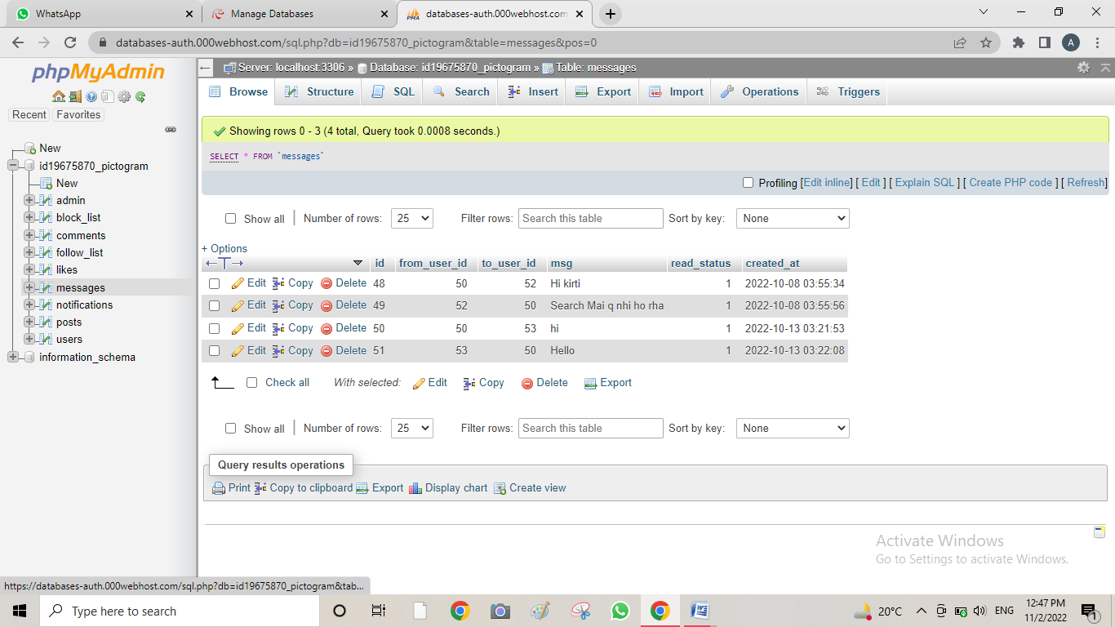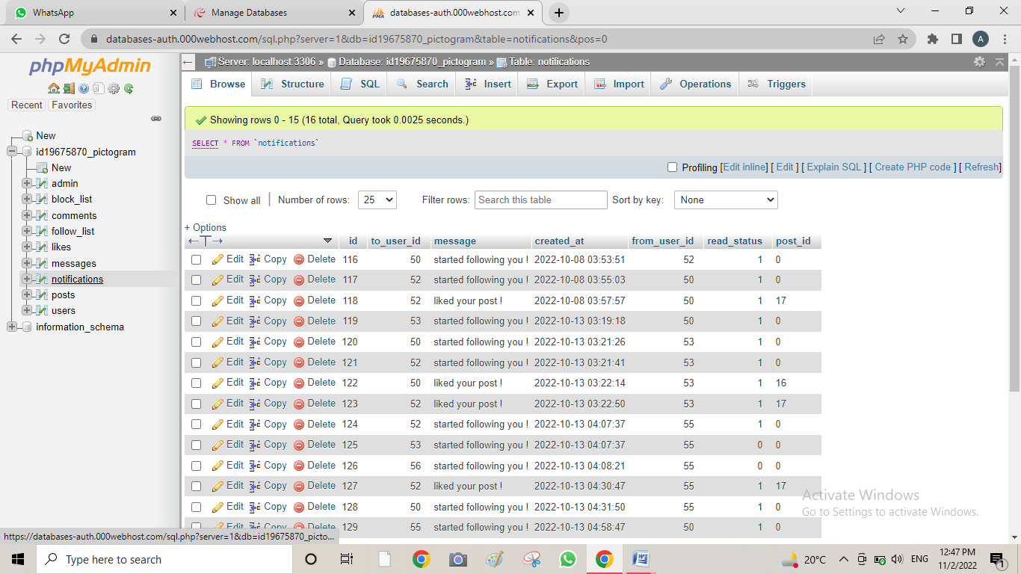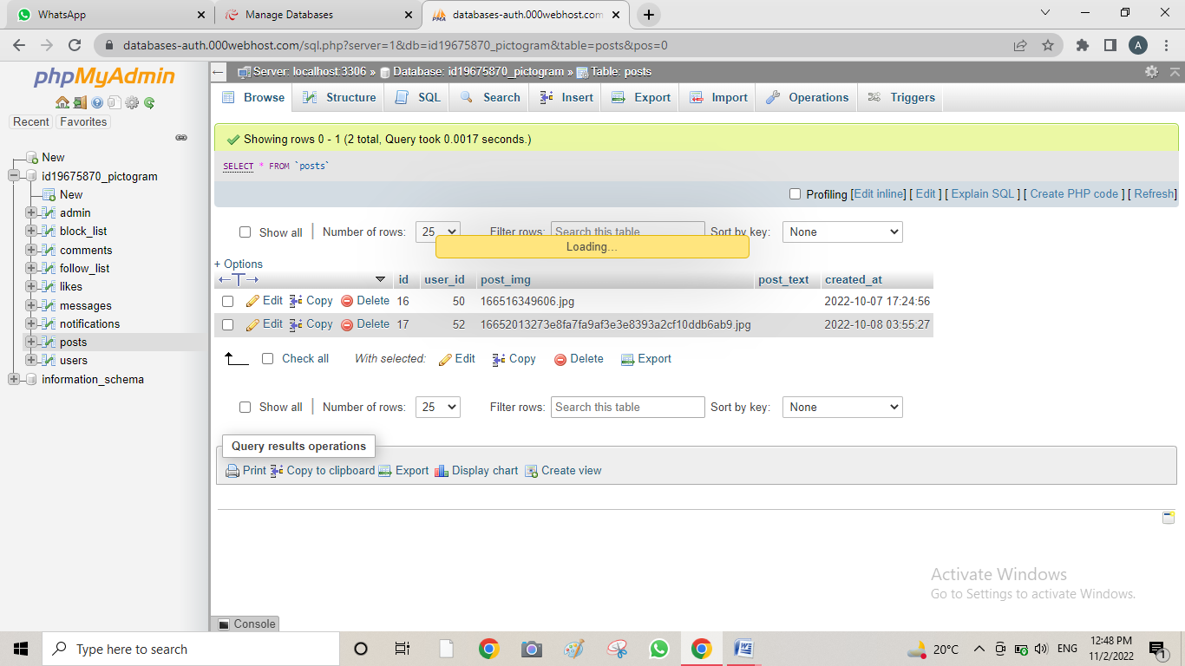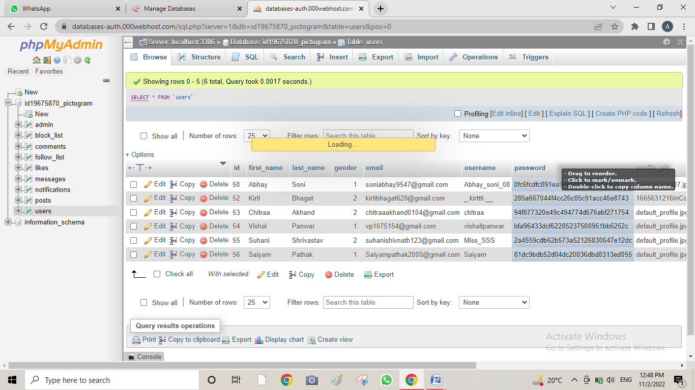

**LIMITATIONS**

**7. Limitations:**

* Decreases face to face communication skills.
* Facilitates Laziness.
* Reduces family closeness
* Causes Distractions.
* Makes us addicted.
* Counterfeit News
* Increased cyber crimes
* Security concern

**FUTURE SCOPE**

**8. Future Scope:**

**1. Growing role of mobile devices:**

91% of all social media users access their favorite channels via mobile devices.Social networks already have specialized ad formats for mobile apps. Mobile -exclusive advertising will continue to become even more popular.

**2. New Features:**

Original function of social network, which are created to allow users to find their old friends online, is the restoration of relationship.

**3. Visual social Networks:**

Video and graphical information have always been more popular than the text. That is why Instagram and Pinterest are actively developed.

**4. Geo-Social Services:**

Companies have already noted such tools as Next door and actively use them to promote products.

**5. Social Recruiting:**

HR specialists are more often turning to social networks when looking for candidates for a particular position. After all. They help to form an idea about the candidate, gat a psychological profile, evaluate the publications, and contact with the former colleagues and managers.

**CONCLUSION**

**9. Conclusion:**

After performing this series of statistical tests on the survey data, the researchers were able to gain a more complete idea of how users view Pictogram. Males and females seem to take away the same experience from their interactions. Different age groups value different attributes above others. Yet, all age groups are majorly concerned with privacy. Privacy settings received high rankings in both importance and improvement.

If Mark pictogram team were to prioritize and tackle any issue out of those discussed in this research, it is apparent that privacy is that issue.  
Through the time spent running statistical analysis and interpreting the results, the researchers have gained insight into how important quantitative analysis is for understanding strengths and weaknesses with customer bases. Additionally, statistical analysis can point out those areas which may be causing multiple problems and rank the importance of tackling these issues, which are not benefits that can be generated from qualitative analysis.

Perhaps the largest lesson learned in the quantitative portion of this social media project was how to visually represent complicated statistical problems in a clear and precise manner. This is a new kind of challenge for the members of this team which will undoubtedly have positive returns in any future careers.

**BIBLIOGRAPHY AND**

**REFRENCES**

**10. Bibliography and References :**

Site link:-

<https://pictogrampg.000webhostapp.com/>

Site Admin Panel link:-

<https://pictogrampg.000webhostapp.com/admin/>

Online Webhosting link:-

<https://www.000webhost.com/>

Database link:-

<https://databases-auth.000webhost.com/index.php>

Theory Part links:-

<https://www.geeksforgeeks.org/software-engineering-software-project-management-spm/>

<https://www.javatpoint.com/software-project-management>

<https://www.tutorialspoint.com/software_engineering/software_project_management.htm>